# **LAB 6: FROG HEART STUDY**

# Introduction

1. Background

# Computer Simulation

1. Frog Heart
2. Sheep Heart Anatomy
3. Frog Anatomy

VII. Study Questions

VIII. Lab Report Guidelines

**Note: We will collect all the class data and use Python and Jupyter notebooks to analyze the collected data. You will receive more information about this during lab. **

# **INTRODUCTION**

In the Excitability and Contractility lab, some characteristics of skeletal muscle were investigated. In this exercise, a second type of muscle, cardiac muscle, will be studied.

Each group of students will dissect a frog. The frogs will be pithed, a procedure which destroys the brain and the spinal cord. This procedure results in a loss of sensory perception, and the subsequent manipulations will cause the animal no pain.

The scientific community is responsible for breeding and raising animals under sanitary conditions, handling them gently during experimental trials, killing them, when necessary, quickly and painlessly, and disposing of the carcasses in a sanitary manner. Scientists are aware not only that they hold a revocable trust of the body politic, but also that humane treatment of animals is necessary for the best scientific purposes as well.

# **BACKGROUND**

Frog Heart

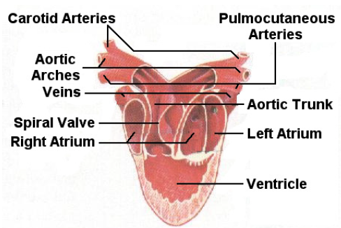The frog heart has three chambers: two atria, and a ventricle, as well as an enlarged region called the sinus venosus (Fig. 1). Blood returns to the sinus venosus from the body via two anterior and a posterior venae cavae. Blood drains from the sinus venosus into the right atrium, which then empties into the ventricle. Blood returns to the left atrium from the lungs via the pulmonary veins. The left atrium also empties into the ventricle. The ventricle then pumps the blood to the arterial cone, which leads to the pulmonary arteries (beginning of pulmonary circulation) or to the carotid arteries and the aortic arch (beginning of the systemic circulation). The presence of only one ventricle that collects blood from both atria causes some mixing of oxygenated and deoxygenated blood. However, the architecture of the ventricle and the presence of a spiral valve in the arterial cone maintain sufficient separation of the blood.

**Fig. 1** Frog heart anatomy

Cell-to-Cell communication in the Heart

The major component of the heart is its muscle layer, the myocardium. Myocardial cells share similarities and differences with both skeletal muscle and smooth muscle cells. One important feature of myocardial cells is that they are joined to each other by intercalated discs, containing desmosomes and gap junctions. Desmosomes are intercellular "staples" which help to hold cells together during heart contraction and swelling. Gap junctions are channels between cells which allow the passage of molecules up to about 1000 KDa. Gap junctions are a low-resistance route between cells, allowing waves of depolarization (positive ions) to spread over the myocardium.

Electrical Activity of the Heart

The heart beat in vertebrates is myogenic in that it originates in the muscle cells (in humans, in the sinoatrial node). In the sinus venosus, cells that possess the fastest inherent rhythm of depolarization and contraction are called pacemaker cells. Although the mechanism for spontaneous depolarization is not fully understood, it results in changes of membrane permeabilities to ions (i.e. the opening and closing of ion channels). The action potential generated by the pacemaker cells then spreads to adjacent cells, eventually resulting in contraction of muscle cells in the atria and in the ventricle. The mechanism of propagation of the action potential in the heart is similar to propagation along an axon. The major difference is that the action potential spreads from one cell to the next through gap junctions. The coupling of the action potential to the contraction of cardiac muscle (excitation contraction coupling) is similar to skeletal muscle. The action potential travels along a T-tubule system, eventually triggering the release of calcium from the sarcoplasmic reticulum. However, in cardiac muscle there are also voltage dependent calcium channels in the plasma membrane. Thus, unlike skeletal muscle, intracellular calcium rises due to calcium coming in from the sarcoplasmic reticulum, but also due to calcium coming in from the extracellular space. Depolarization of cardiac muscle is characteristically longer than that of skeletal muscle. This results in a longer absolute and relative refractory period, which prevents myocardial tetanus from occurring.

The summed electrical activity in the heart can be recorded and displayed as an electrocardiogram (ECG). We will record the ECG of the frog heart using electrodes that sit on the exposed heart. You will likely see a pattern of peaks that looks like this:

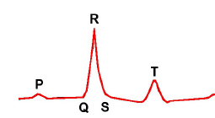

The P wave corresponds to the atria depolarizing. The QRS complex is the ventricle depolarizing and the T wave is the repolarization of the ventricle. We will learn more about the ECG in the next lab, but for now we will use the R wave to measure the rate of the heartbeat and the amplitude of ventricle contraction.

Autonomic Control of the Heart

The inherent rhythm of the heart is modulated primarily by the autonomic nervous system and the endocrine system. The parasympathetic innervation, via the vagus nerve, releases acetylcholine, which decreases heart rate. The sympathetic innervation releases norepinephrine, which causes an increased heart rate. Epinephrine (also called adrenaline), which resembles norepinephrine, is released by the adrenal medulla, and has similar effects on the heart.

# **COMPUTER SIMULATION**

We will simulate today’s experiments with the frog heart using a program called PhysioEx. Using the lab manual provided with the computer, do the sections listed below. Under each section you will find instructions that will guide you through the simulations. There are two main experiments you will be running: Electrical Stimulation and Modifiers of Heart Rate, which you can find in the Experiment Menu. Note that the program measures the force of contraction and not the ECG like you will be doing. You do not need to include your simulations with your lab report. However, these simulations should help you understand the success and failures of the experiments that you will perform in the lab.

Simulation Activities:

1. Direct heart stimulation

2. Vagus nerve stimulation

3. Effect of epinephrine and pilocarpine (an acetylcholine receptor agonist)

4. Effect of Temperature

5. Effect of ions (K+ and Ca2+)

**IV. FROG HEART**

**Frog dissection and observation of the heart**

Before you begin, read the Comments on Technique box in a couple of pages.

1. Turn the frog so it is on its back in the dissection tray. Lift up on the skin just below the abdominal area and make a small cut to expose the muscle and connective tissue layer underneath. Make a cut from just beneath the abdominal area all the way to the mouth of the frog and then peel the skin back on both sides. Whenever you do cuts like this, keep your scissors tilted upward, so the tips are angled away from the frog. This will prevent you from cutting the next layer of tissue below.

2. Note the blood vessels in the skin and the layer of muscle and connective tissue that completely surrounds the abdominal cavity. Lift up the abdominal muscle layer and make a small incision revealing the contents underneath. The layer of muscle and connective tissue should now be more apparent. Cut all the way through the sternum and ribs. These are hard bones, so you will have to use force to get through them.

3. Under the sternum are the heart and the lungs. Note that there is no diaphragm. The heart of the frog has three main chambers. These are the right and left atria and a single ventricle. Identify the three chambers. Observe the order of the heartbeat. The heartbeat originates in the sinus venosus, an enlarged region between the large vein returning to the heart (vena cava) and the right atrium (this is sometimes referred to as a fourth chamber). The heart beat then travels to the two atria and then to the ventricle.

4. Carefully free the heart of its surrounding sac called the pericardium. Be careful! **Do not remove the heart from the frog – the heart needs to be exposed but must remain attached to the frog**. Note the thin-walled atria, each partially hidden by the ventricle. Also, find the sinus venosus, a V-shaped, very thin-walled structure. It may be seen by raising the ventricle. The sinus venosus receives the posterior vena cava and the two anterior venae cavae. It empties into the right atrium. Make the following observations: Which parts contract rhythmically? What is the rate of contraction of the ventricle? The atria? What is the sequence of action of the parts? Note the color of the ventricle in systole and diastole.

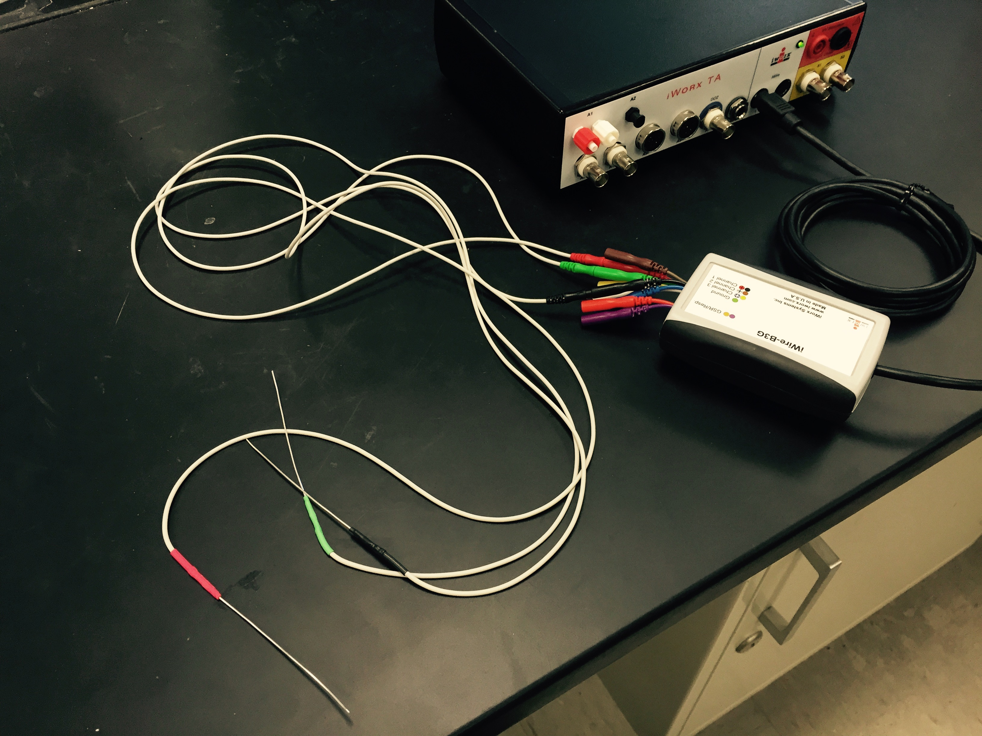

**Fig. 2**

**Placement of electrodes**

1. You will be using three electrodes (Figure 2). The green electrode is the ground and will be put in an area away from the heart. The red and black electrodes are going to sit on top of the heart (Figure 3).

2. Untangle the electrode wires and move everything away from the dissection tray and frog. Once the electrodes are placed, you don’t want to accidentally touch them.

3. Cut a small hole in the skin of the left upper forelimb of the frog (the arm furthest from heart). Insert the green electrode needle through the hole in the skin and push it into the muscles (Figure 3). Do not go through the muscles into the tray below.

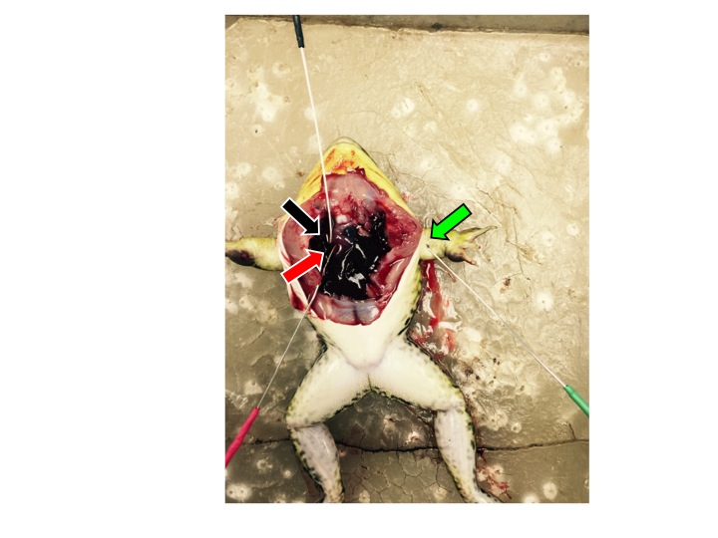

**Fig. 3** Placement of the electrodes in the dissected frog. Arrows indicate where the tips of the electrodes go.

4. Carefully adjust the positive red recording electrode so it is resting on top of the ventricle (the bottom part of the heart). You may need to rest the electrodes on books or other objects to get the right angle. Use the tape to secure the electrodes to the dissection tray.

5. Position the negative black recording electrode so it rests just below the A-V groove (between the atria and ventricle) slightly to the frog’s left.

6. Both electrodes should rest *on the heart* on their own without anyone holding them. This may take some time to get things just right, so be patient.

**Recording ECG**

1. The software is probably already loaded, but if you need to, choose the setting file called “Frog Heart.”

2. Record the ECG. It should something like Figure 4.

Do you see all the peaks of the ECG? If the ECG is upside down then you can invert the signal (using the menu to the left of the ECG window (look for the arrow)).

There should also be a recording of the heart rate in the bottom window. If the value is zero, then jiggle the red and black electrodes a little bit and move them slightly, so they make better contact with the heart. The values in the heart rate window are not always accurate (they depend on how well the electrodes are making contact with the heart), so always determine heart rate manually by counting the number of R waves in a minute.

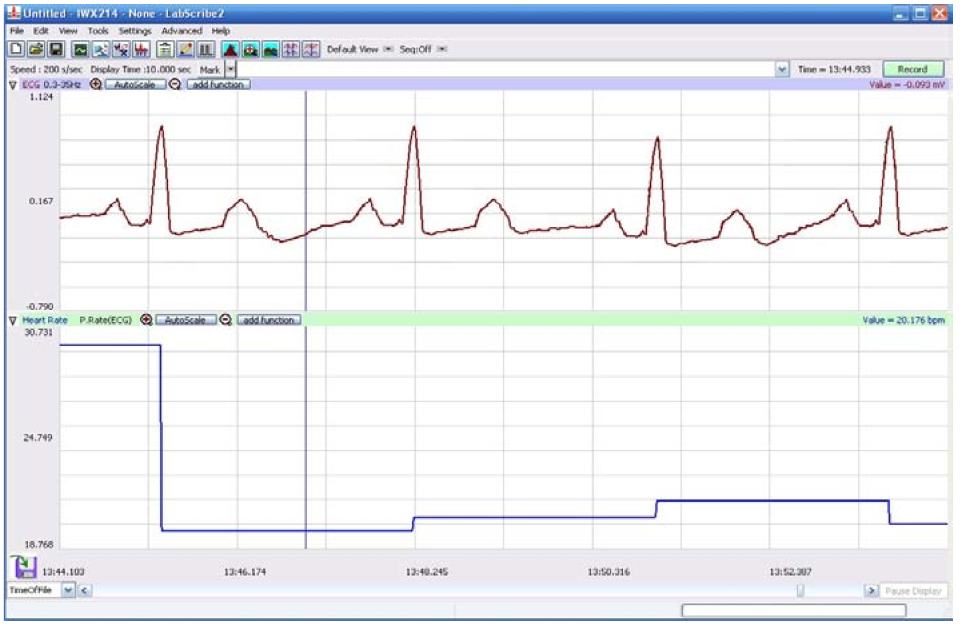

**Fig. 4** Recording of frog ECG. The top window is the ECG and the bottom window is the heart rate calculated from the ECG.

**Comments on Technique**

1. Keep the heart moist with Ringer's at all times.
2. Try not to touch the electrodes during recordings.
3. Wear gloves when dissecting the frog.
4. You may need to reposition the electrodes after putting solutions on the heart.
5. Try your best, but don’t get discouraged if the frog heart doesn’t last through the entire experiment. If this happens, the class will pool their data together.
6. Clean up all dissection equipment with 70% ethanol before you leave.

### Once you have a good set-up to record the frog heartbeat, start with the experiment assigned to you by the GSI. Everyone will start with a different experiment and then work their way through the other experiments. It is possible that the heart will not make it through all the experiments, but you will be sharing data with the entire class, so that is okay. Try as many as you can.

### Influence of temperature

For all experiments you will first obtain a baseline recording for 3 minutes, then a 3-minute recording for the particular manipulation, then a second 3-minute baseline recording.

1. Put room temperature Ringer’s solution on the heart to get a stable baseline recording. The heart rate is in the bottom window, but you can also double check the value by measuring the heart rate. To measure heart rate, first obtain a recording of 3 minutes. To obtain the heart rate, count the number of R wave peaks that occur in one minute. Since you should have 3 minutes of recording you can obtain 3 heart rate measurements and then take the average. This is your baseline heart rate before any experimental manipulation. Enter the heart rate in **Table 1**. Also measure and record the average amplitude of the R wave, which correlates to the strength of the ventricle contractions.
2. Measure your own heart rate. What is the resting heart rate in a typical human?
3. Obtain a stable heart rate measurement at a higher temperature. Carefully drop warmed Ringer's over the heart with an eyedropper and wait until the heart rate stabilizes. If the ECG changes immediately, that is probably because the electrodes have been displaced. Try to get them back onto the heart. Obtain a stable recording for 3 minutes and measure the heart rate and amplitude as described in step 1 above.
4. Obtain a second stable heart rate measurement at room temperature for 3 minutes. Rinse on a solution at normal room temperature, and obtain a stable recording before moving on to cold temperature.
5. Repeat step 3 with Ringer's that has been chilled on ice. Enter all your data in **Table 1**.

**Table 1: Temperature effects**

|  |  |  |
| --- | --- | --- |
| **Condition** | **Heart Rate** | **Amplitude of R wave** |
| Human heart rate |  | **N/A** |
| Baseline frogheart rate |  |  |
| Warm temperature |  |  |
| Baseline before cold |  |  |
| Cold temperature |  |  |

### Influence of neurotransmitters

1. Obtain a baseline recording for 3 minutes at room temperature. Measure heart rate.
2. Apply epinephrine directly to the heart with 1-2 drops. Wait until you have a stable heart rate (this could take up to 10 minutes). Obtain a stable recording for 3 minutes. Observe any changes in the strength of contraction. Measure the heart rate and R wave amplitude.
3. Rinse thoroughly with normal Ringer's. Wait several minutes for heart rate to return to baseline. Obtain a stable recording for 3 minutes and measure the heart rate.
4. Repeat steps 1-3 with acetylcholine to the heart. Enter all your data in **Table 2**. If acetylcholine stops the frog’s heartbeat, you should wash it out and try adding a drop of epinephrine.
5. Rinse with normal Ringer’s before proceeding with other experimental manipulations.

**Table 2: Neurotransmitter effects**

|  |  |  |
| --- | --- | --- |
| **Condition** | **Heart Rate** | **Amplitude of R wave** |
| Baseline(before epinephrine) |  |  |
| + epinephrine |  |  |
| After wash out(new baseline) |  |  |
| + acetylcholine |  |  |

### Influence of electrolytes (ions)

1. Obtain a baseline recording for 3 minutes at room temperature. Measure heart rate and amplitude of the ventricle contraction.
2. Apply a potassium chloride solution to the heart in several drops and wait for the heart rate to stabilize (this increases extracellular K+ levels). Obtain a stable recording for 3 minutes. Note any changes in the shape of the pulse. Measure heart rate and amplitude.
3. Rinse with normal Ringer's. Obtain a stable recording for 3 minutes. Measure heart rate.
4. Repeat steps 1-3 with a calcium chloride solution (this increases extracellular Ca+2 levels). Enter your data in **Table 3**.

# **Table 3: Effects of electrolytes**

|  |  |  |
| --- | --- | --- |
| **Condition** | **Heart Rate** | **Amplitude of R wave** |
| Baseline(before KCl) |  |  |
| + KCl |  |  |
| Baseline(before CaCl2) |  |  |
| + CaCl2 |  |  |

Enter your data in the spreadsheet provided to you by the GSI. In your lab report, include the data you collected in Table 1, 2 and/or 3. You should also include the averaged class data for these tables and make graphs using the class data.

**V. SHEEP HEART ANATOMY**

Unlike the frog heart, the sheep heart has four chambers, similar to the human heart. There are two atria and two ventricles, so oxygenated and deoxygenated blood is kept completely separate.

Look at a sheep heart dissection on demonstration and make a labeled drawing to include in your lab report. Make sure your drawing identifies the following structures:

* Right atrium associated with the cranial and caudal venae cavae.
* Left atrium and associated pulmonary veins.
* Right and left ventricles and atrioventricular valves. Why is the left ventricle bigger than the right ventricle?
* Pulmonary trunk, carrying blood from the right ventricle
* Aorta, carrying blood from the left ventricle.
* Coronary arteries, which branch off of aorta and lie on the surface of the heart between the left and right ventricles. What is the function of the coronary arteries?

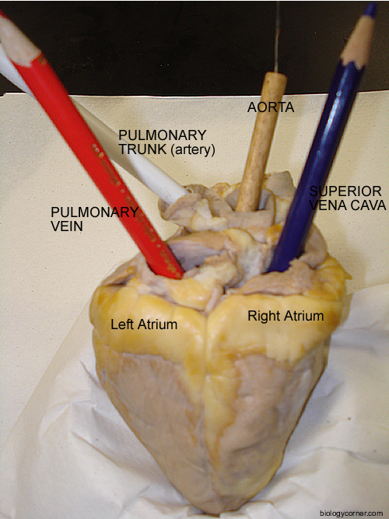

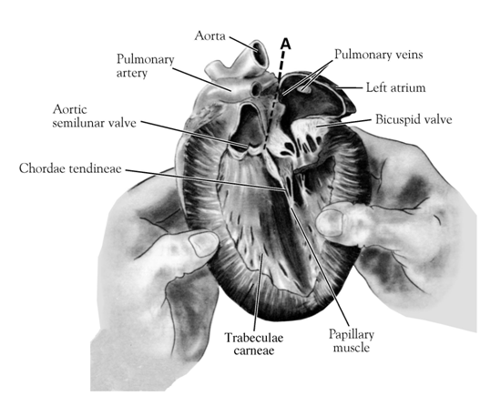

**VI. FROG ANATOMY**

When you are done with the heart experiments, you should dissect your frog. This is a self-guided learning experience for your own benefit. You do not need to include the frog dissection in your lab report.

Identify structures: After the abdominal and thoracic cavities are opened, look for the following structures:

1. Esophagus, stomach, small intestine, large intestine, pancreas, cloaca, gallbladder, spleen, liver, fat bodies, kidney, adrenal glands, heart, lungs.
2. Push aside the digestive tract to find the urogenital system: kidneys, ureter, bladder, and gonads (testis or ovaries).

Use the lab computers to look online for frog dissection guides to help identify structures.

# External Anatomy

# Note the skin texture and color variation. The skin serves as an organ of respiration, excretion, and water and electrolyte balance. The skin contains both mucous and serous glands for lubrication. Finally, the skin has nerve endings for the senses of touch, pressure, and taste. Behind the eyes are two rounded depressions covering the tympanic membrane. By pressing on the skull between the eyes, the eyes can be made to pop out, revealing the lower eyelid or nictitating membrane.

# Pleuroperitoneal Cavity

# Look at the inside of the skin again and note the blood vessels. Why does the frog skin have so many blood vessels?

# Within the pleuroperitoneal cavity, you should be able to find the liver (it’s very large and has three lobes), gallbladder and pancreas. You may be able to find the esophagus, and the large stomach connected to the small intestines, cecum (a pouch between the small and large intestines) and the large intestine, which passes feces to the cloaca. Also look for the lungs (which may be under the heart), the spleen and fat bodies. If you’re feeling brave, try cutting open the stomach and intestines to see what’s inside.

# Urogenital System

# Push aside the digestive system. You can make a cut up near the esophagus and then down below the large intestine and note the length of the digestive system. Find the kidneys and then try to find the bladder (often hard to find). The kidneys are long paired structures on either side of the midline. The adrenal (suprarenal) is a strip of yellow tissue directly adherent to the ventral surface of the kidney. See if you can trace the small tube that runs from the kidney to the bladder: this is the ureter (often hard to find). Is your frog a male or a female? The gonads (either testes or ovaries) in both sexes lie directly on the kidneys. The oviduct extends from the root of the lungs to the cloaca.

Nerves and Veins

# With all the abdominal contents pushed aside see if you can find the ventral vein, which runs up the dorsal side of the abdominal cavity. Notice the nerves that run down towards the legs. What happens if you squeeze on the nerves with forceps? Can you tell which nerve is connected to which muscle? Notice the spinal cord that runs along the back of the frog. In an area closer to the heart and lungs, cut out a small section of the spinal cord and try to push the white mass out from the spinal cord using one of the probes. The pithing procedure should have destroyed these nerves.

Mouth Structure

# Open the jaw and observe: in the roof of the mouth two paired openings, the posterior nares and the eustachian tube; in the floor of the mouth, the extensible tongue and the vocal sac openings (males only). Which jaw has teeth?

# The Frog Eye

# Excise the eye by cutting the bone above the orbit. Be careful, fluid can sometimes squirt out unexpectedly. Cut the eye around its equator. Identify the cornea, lens, and vitreous humor. With forceps, scrape the retinal and pigment layers from the back of the eye cup.

# **CLEAN UP:** Frogs and any tissue go into the red bags. Rinse your dissection pans in the sink. Clean all dissection tools and electrodes in 70% alcohol or with alcohol pads to remove blood.

# **VII. STUDY QUESTIONS**

1) Summarize the effects of warm and cold temperature on the heart. Explain why temperature affects the heart rate.

2) When it is cold outside, do you think your heart rate changes as much as the frog’s heart rate in this experiment? Briefly explain.

3) Summarize and discuss your results for the neurotransmitter experiments. Are your results what you expected? Explain.

4) Individuals who smoke cigarettes can accidentally poison the heart by touching it. What chemical is released from the hands onto the heart and what does it do to the heart?

5) How does the autonomic nervous system regulate heart rate during exercise?

6) Summarize your results with the electrolyte solutions. Do your results match your hypothesis? Explain why Ca+2 and K+ affect the heart rate.

7) Lethal injections contain a high concentration of potassium chloride. Why use potassium chloride and not sodium chloride? How does this cause death?

8) Digitalis is a compound used clinically in certain cardiovascular diseases. Digitalis blocks the Na+-K+-ATPase pump. This decreases Na+ flux out of the cell and thereby decreases the sodium gradient between the outside and inside of the cell. This lowers the ability of the Na+-Ca2+ exchanger to pump calcium out of the cell. Would this cause the heart muscle cell to contract more forcefully or less forcefully? Why?

**VIII. LAB REPORT GUIDELINES**

**Introduction (20)**

* What is the purpose of the lab? What physiological process are we studying and what are we hoping to learn? (5)
* Background for experiments (10)
  + Differences between the frog and human hearts (this might be a good place to include the sheep heart drawing you did)
  + Electrical conduction through the heart
  + Regulation of heart rate by autonomic nervous system (which neurotransmitters are used)
* Hypotheses: you need three different hypotheses, one for each set of frog heart experiments (temperature, neurotransmitters, electrolytes) (5)

**Methods (15)**

* Briefly describe the positioning of the electrodes on the heart (no need to describe dissection)
* Describe how you did the three experiments:
  + Timing of changing solutions
  + How much solution did you add?
  + What parameters did you measure?
  + Which data is yours and which did you get from other groups?
* Do not describe the experiments involving sheep heart anatomy or the rest of the frog dissection

**Results (25)**

* Include your data for Tables 1-3 as well as the averaged class data. Make a graph of the class data for the heart rate, so it is easier to visualize the data. (10)
* Remember to label all tables and figures and include legends (5)
* Write about the major trends you see in the data, both for the heart rate and amplitude of the R wave. (8)
* Remember to include the sheep heart anatomy drawing somewhere: it could be in the results or introduction or at the end of the lab report (2)

**Discussion (30)**

* Did the experiments support your hypotheses? Explain. (10)
* Connection to physiology (10)
  + Explain the physiological reason for all three experimental results. If you did not get the expected results, you should still explain the physiology behind what you expected. Focus on the heart rate here rather than the R wave amplitude. (Study questions #1, 3, 6)
  + When would the sympathetic nervous system normally regulate heart rate? Why? (Study question #5)
  + Answer one more of the study questions (#2, 4, 7 or 8)
* Suggest improvements to the experiment (5)
* Discuss a future experiment you could do to follow-up on your findings. Include the hypothesis for the new experiment. (5)